Opiate Prescriptions & Overdoses

**CREATED BY**: ROY SUBHADEEP (A20358508),

BOTHARA SHUBHAM (A20383550)

**INSTRUCTOR**: ADAM M. MCELHINNEY

**COURSE**: CSP-571 DATA PREPARATION AND ANALYSIS

**SCHOOL**: ILLINOIS INSTITUTE OF TECHNOLOGY, CHICAGO

# MOTIVATION AND BACKGROUND

Over the past 15 years in United States, deaths from opioid prescriptions have increased four folds.

Daily approximately 113 people die in U.S. due to drug overdoses and nearly half of the yearly deaths occur due to overdoses. There were more than 38000 deaths in US in 2010 and which also exceeded the deaths by motor accidents in 2011. This has remained a serious concern over the years and CDC (Centre for Disease Control & Prevention) characterized this as an epidemic in 2012 with most deaths deemed preventable.

The massive increase in largely due to the use of opioids as pain relievers while the level of pain experienced by most Americans remains largely unchanged.

Intuitively it follows that unnecessary prescriptions play a significant role in drug overdoses. Patients who do not need it, run the risk of becoming addicted themselves or they are tempted to sell their refills for significant profits, increasing the supply of narcotics in the illegal drug market.

Over the years this has been a very active area of research. An effective strategy in identifying instances of overdoses can be a life-saving endeavour.

In the end, the goal remains to use machine learning techniques to predict likelihood that a given prescriber is a prescriber of opiates.

# SCOPE OF ANALYSIS

This is a very active area of research and there are plenty of studies to perform. However, the scope of this document remains restricted primarily to detecting sources of significant quantities of opioids and other statistical findings. This study is restricted to the below analysis.

* Detecting primary sources of opiate prescriptions.
* Statistical findings on demography for patterns and trends.
* Detection of important drugs, prescriber’s specialty and other important features contributing more toward the prediction.
* Examine overdose deaths in race and age groups.

# DATA EXTRACTION

All the data is available under public domain license and can be downloaded from CMS (Centre of Medicare and Medicaid services) and CDC (Centre for Disease Control and Prevention) websites.

* Prescriber Data: The prescriber data is downloaded from <https://www.cms.gov/>. The available data is only for the year 2013 and 2014. For this study only 2014 data has been used. The 2014 zip file contains data spread across two files, drug information and prescriber metadata.

The file PartD_Prescriber_PUF_NPI_14.txt contains prescriber metadata and PartD_Prescriber_PUF_NPI_Drug_14.txt contains the drugs prescribed by the prescribers under Medicare Part D plan.

The total size of the dataset is 2.5 GB. The data which is available is in long format. Each prescriber Id (NPI) is spread across multiple rows based on the drugs that they have prescriber. Below is the structure of the file.

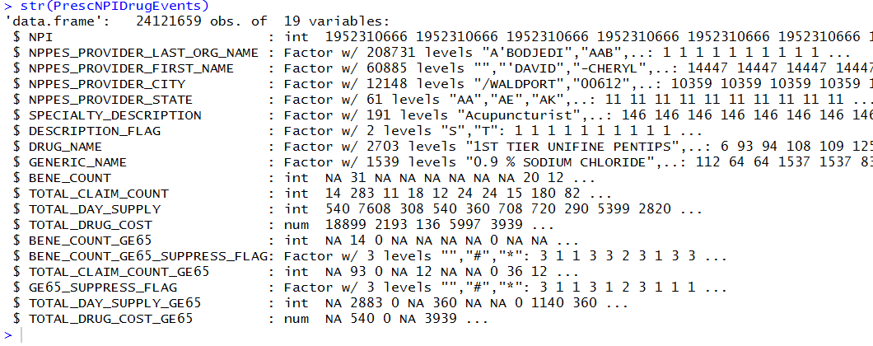

* Drug Category information: This dataset is also available in the CMS website. This data classifies drug names into four categories, opioids, antipsychotics, antibiotics and high risk medications.
* Demography Data: Demography data can be downloaded from CDC website <https://wonder.cdc.gov/controller/datarequest/D76>. This downloaded data has the number of deaths per population for drug/alcohol induced cases in 2014 and has been grouped under state, race and age group. However, there are many other ways it can be downloaded.

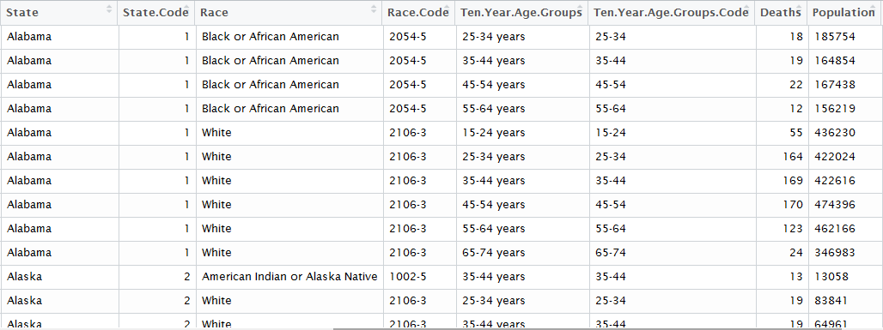

# DATA FORMATTING & CLEANING

FORMATTING

The downloaded data is merged and formatted before analysis and modelling. The prescriber information in long format is converted into wide format so that NPI is the primary key and all the related drug prescriptions are now split into multiple columns. Then the prescriber metadata is merged to the main dataset to add some details about prescriber information.

The top 250 drugs out of 2700 drugs are selected based on the quantity prescribed. This subset is majorly done to reduce the computational overhead due to hardware limitations. The scope was intended to expand but it did not go very well with the individual pc’s.

A binary target label is created if the prescriber has prescribed even one opioid drug or not. The final format of the main dataset is 257 columns where 250 of them are drugs prescribed, 6 columns are prescriber information and one target label.

The demography data is filtered on drug induced cases and alcohol related death rows are removed. Only columns of importance and kept. Basic cleansing operations like removing extra statistics and NA values are performed.

**R Libraries Used:** deplyr, tidyr

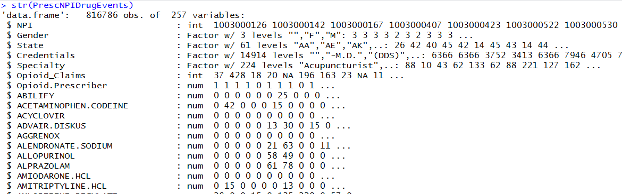

CLEANING

The following summarizes the cleaning operations performed on the dataset.

* Fixing 61 states and incorrect abbreviations.
  + Correct state codes and abbreviations are web scraped using rvest from <https://www.infoplease.com/state-abbreviations-and-state-postal-codes>.
  + State names are manually fixed in the demography data and matched to produce correct abbreviations.
  + State codes are matched and any incorrect state codes are changed to “other” category.
* Opioid drug columns are removed from the main dataset. This is done as it makes the prediction very obvious. Not many columns are removed indicating the top drugs are not opioids.
* Columns are converted into appropriate types.
* 24% of the opioid claim columns has NA values. Since claims are the drugs prescribed including refills, it is safe to assume the NA values to be 0.
* One gender is missing. The same row had a miss in specialty as well and hence it is dropped.
* 3.12% credentials are missing. We set it as NA as we already have an others category.
* Credential columns contain a lot of junk and inconsistent values. Fixing this is not possible as there are over 500 factors probably due to errors. However, this is column can be compensated by Specialty column which is much cleaner and carry the same importance as credentials.
* Any drug columns totalling to 0 amount is rechecked for removal.

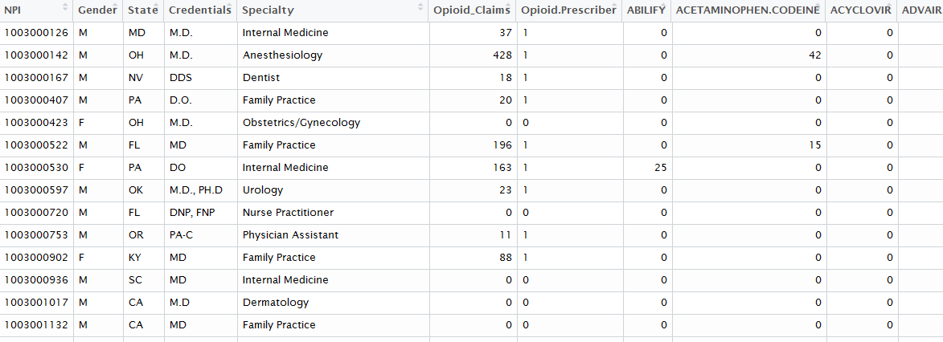

# DATA ANALYSIS

Exploratory analysis of the data was performed to understand the relationship in data.

CORRELATION PLOT

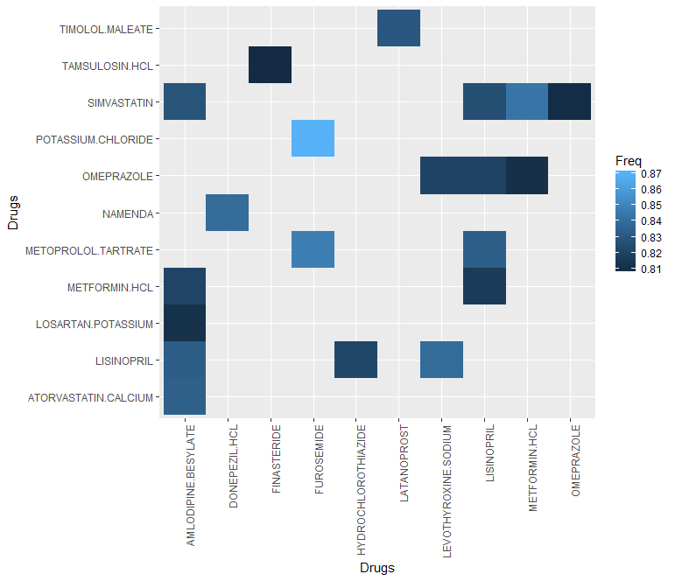

There is a high correlation between Potassium.Chloride and Furosemide. This combination is usually prescribed to treat fluid retention (edema) in people with congestive heart failure, liver disease. Similarly, other drugs too are prescribed in critical situations only, as they have big side-effects.

BAR PLOT

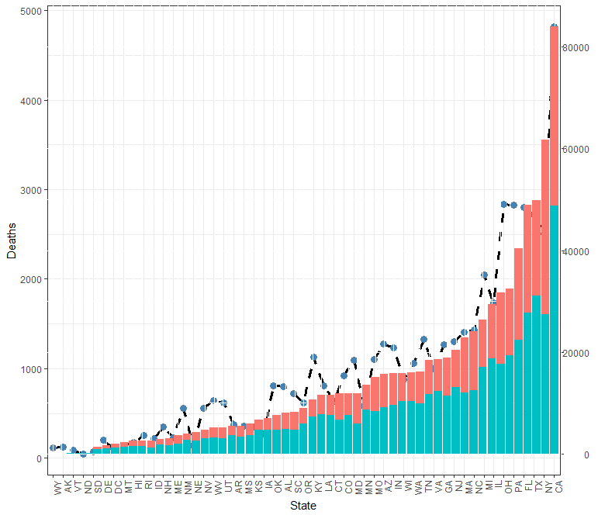The bar chart shows the number of prescribers in a state, filled with opioid(blue) and non-opioid(red) prescribers with its y-axis on the right side. The line plot shows the number of opioid related deaths according to states with its y-axis on the left side. It can be seen from the plot that there exists a strong relationship between opioid related deaths and opioid prescription in states, with higher correlation in California, Texas, New Mexico Florida.

BAR PLOT

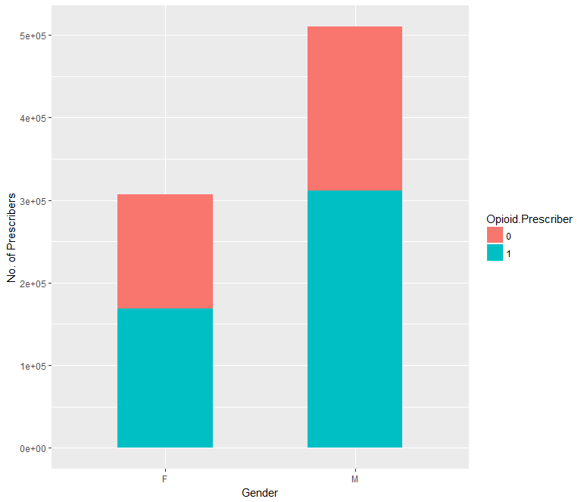The bar chart plots the relationship between the gender of prescriber and their prescriptions. The ratio of No. of Opioid Prescribers to non-opioid prescribers seems to be higher in females.

BAR PLOT

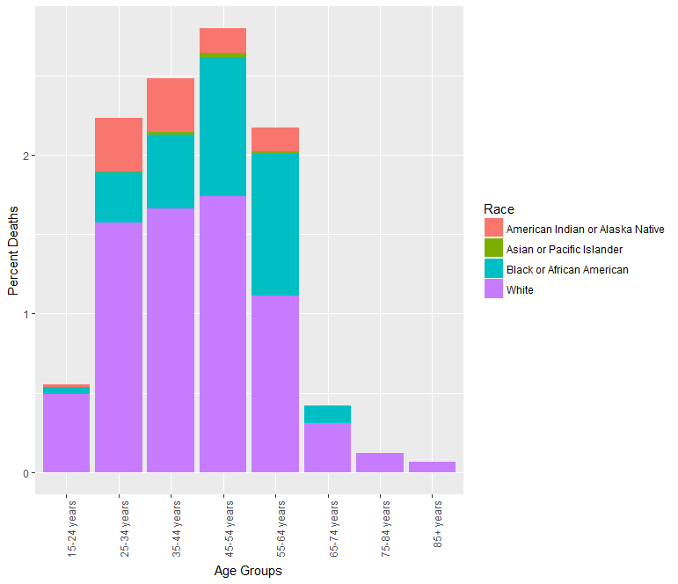

To understand the relationship between age, race and opioid related deaths, we plotted the above graph. From the above bar chart, we can say that across all age groups there seems to be higher opioid related deaths in white people.

RMAP PLOT

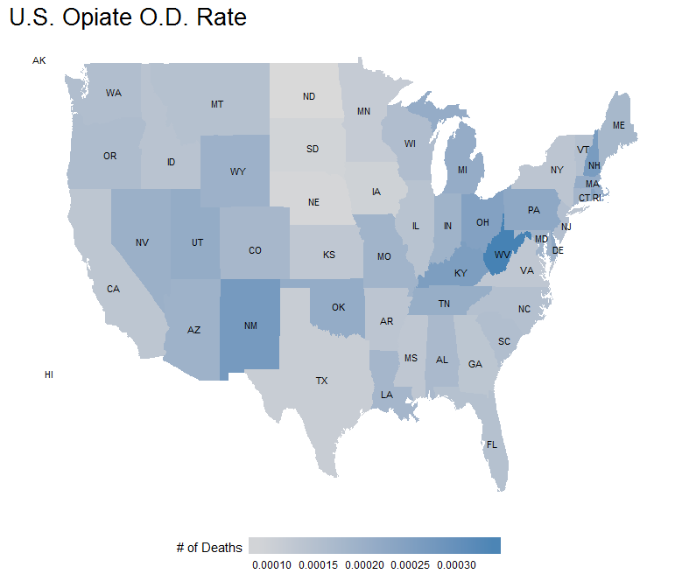

Plotting the death per capita on the state to analyse if there exists a relationship between the geographical location of state and opioid related deaths. There seems to be higher Opioid related deaths percent in the boundary and closer to boundary states with exception to North Dakota. Also, there seems to be stronger correlation in the state of New Mexico and West Virginia.

WORDCLOUD



# PREDICTIVE MODELLING TECHNIQUES

DATA TRANSFORMATION

One-Hot Encoding:

Few categorical columns like specialty and states can be of paramount importance when it comes to predicting opioid prescriptions and therefore must be scored separately. 50 states and around 250 specialties are binary encoded using dummies library in R. Creating a dummy was preferred over creating a model matrix as it retains the convenience of a data frame. The final data set after transforming now contains 496 columns.

STRATEFIED SAMPLING:

Data is partitioned into 80-20 train test datasets using caret stratified sampling.

MACHINE LEARNING MODELS

RANDOM FOREST:

Random forest is optimized using caret train control cross validation using 5 folds/no-repeat and grid tuned. This is computationally expensive hence could not be further improved. It is scored against accuracy metric.

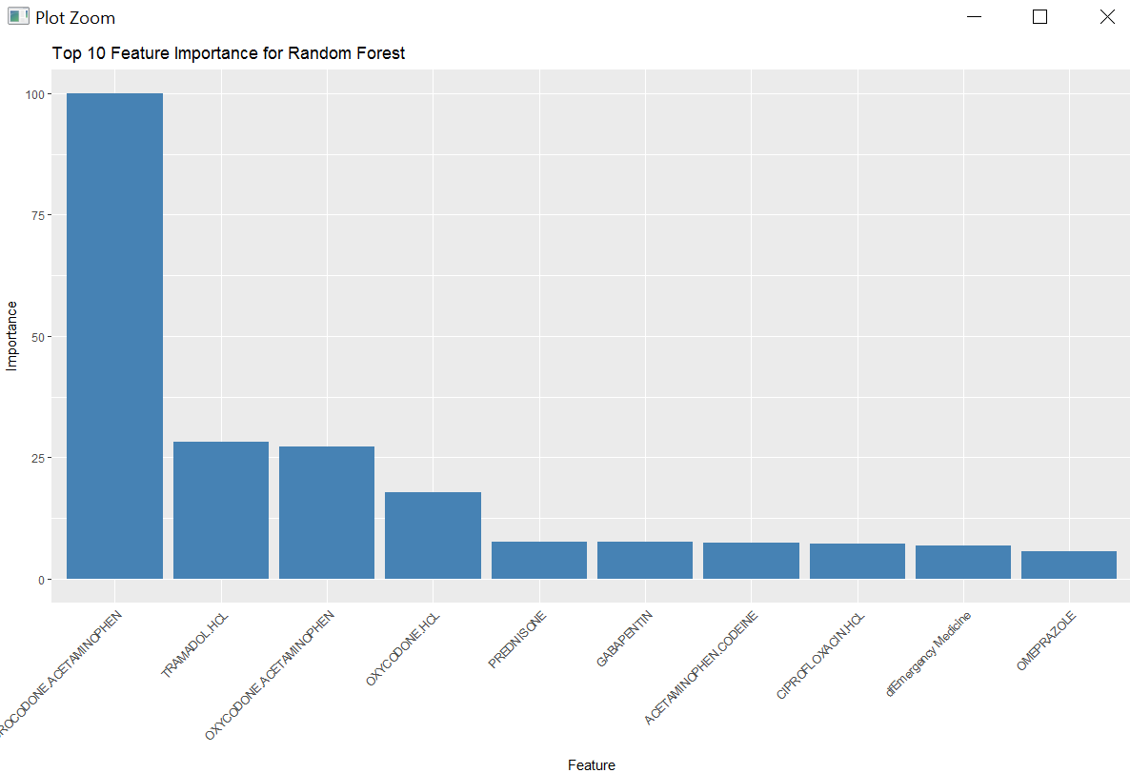

|  |  |
| --- | --- |
|  |  |

LOGISTIC REGRESSION (GLM):

GLM is optimized using caret train control cross validation using 5 folds/no-repeat and binomial family. It is scored against accuracy metric. It is used for its ease of understanding.

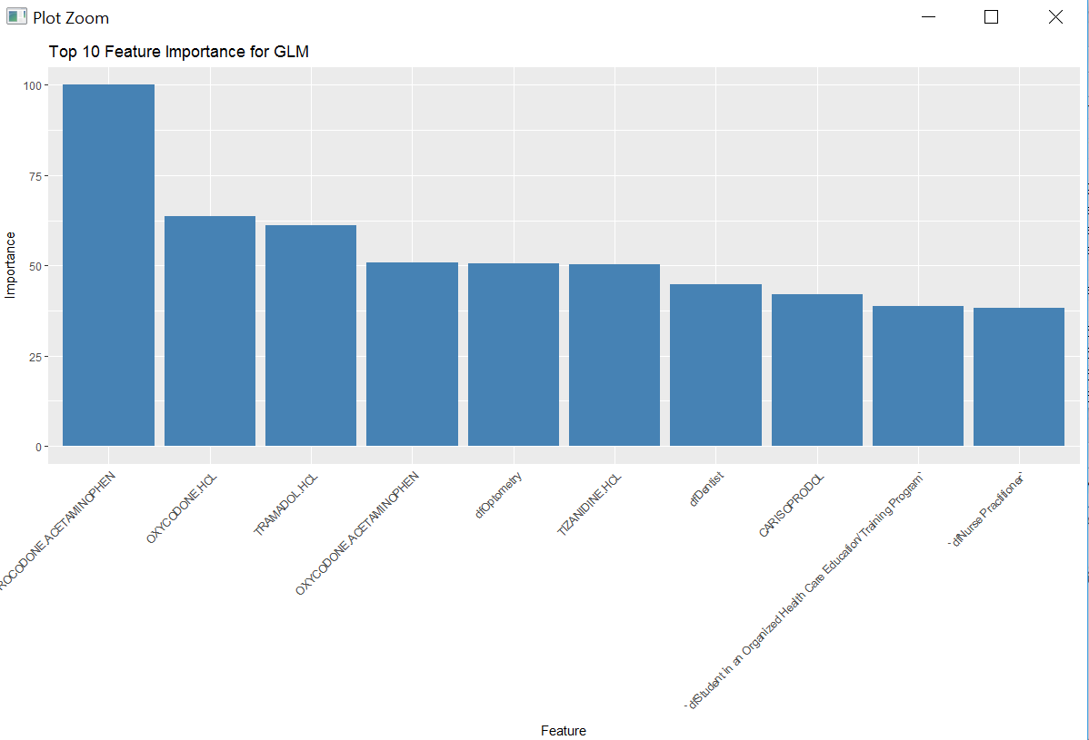

|  |  |
| --- | --- |
|  |  |

NAÏVE BAYES:

The reason for choosing Naïve Bayes is that it is easy to understand and does not take correlated drug columns into account. Laplace smoothing is not used and it performed very poorly.

|  |  |
| --- | --- |
|  |  |

K-NEAREST NEIGHBOUR:

KNN is optimized using caret train control cross validation using 5 folds/no-repeat. It is scaled using “pre-Process” function in caret. It is scored against accuracy metric and best performed at k=23.

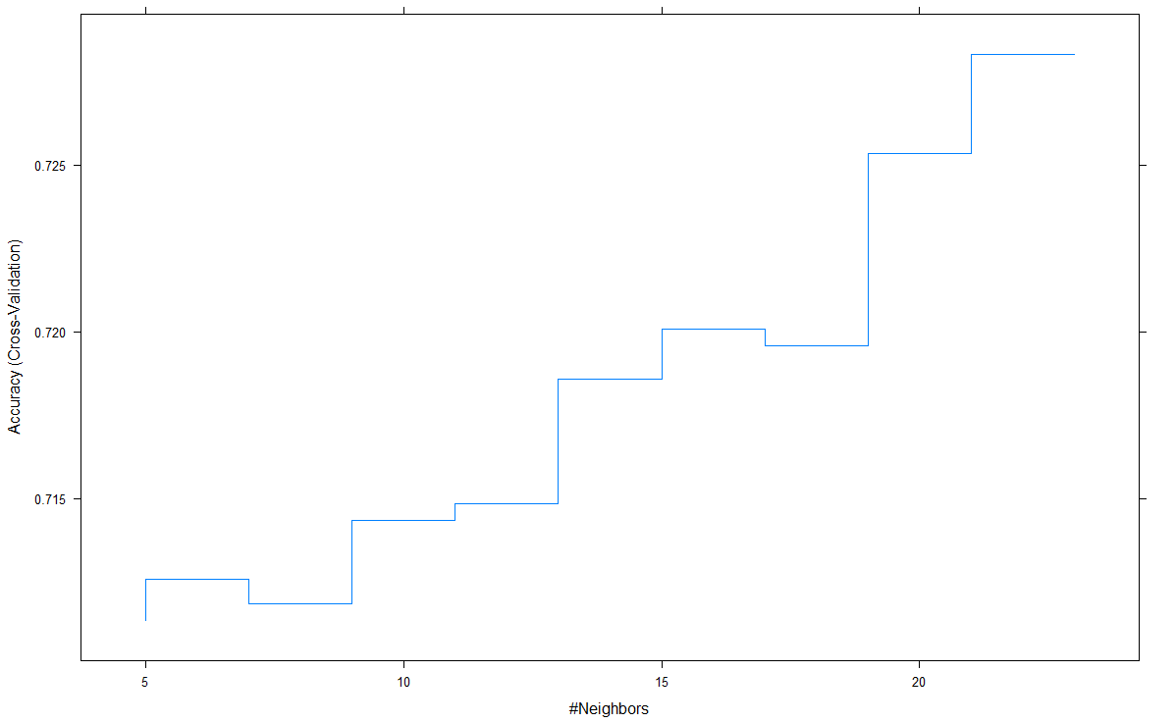

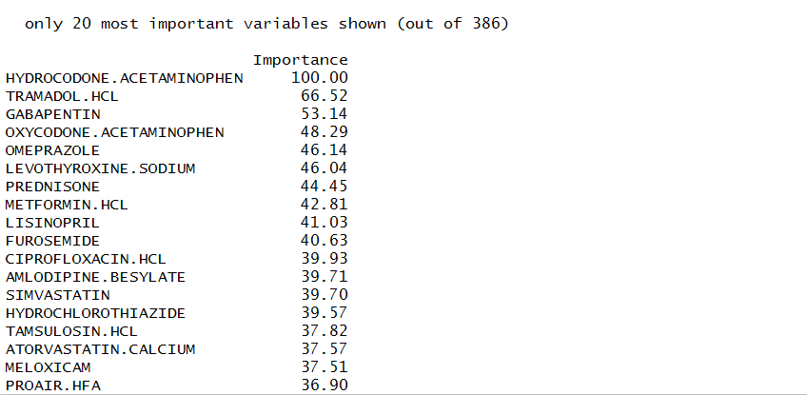

|  |  |
| --- | --- |
|  |  |

LOGISTIC REGRESSION (GLM) with LASSO:

Lasso is optimized using caret train control cross validation using 5 folds/no-repeat to find the optimal lambda value. It is scored against accuracy metric. It is great for identifying features but CV train time is insanely high.

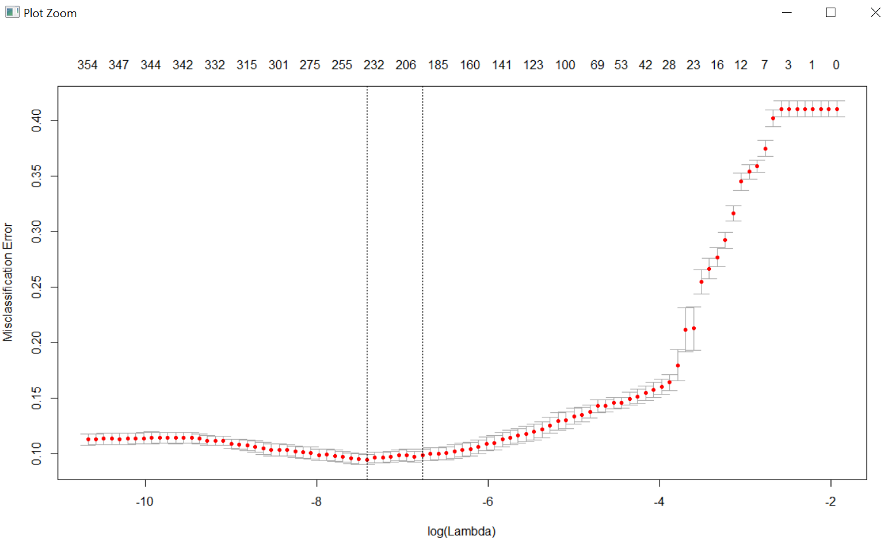

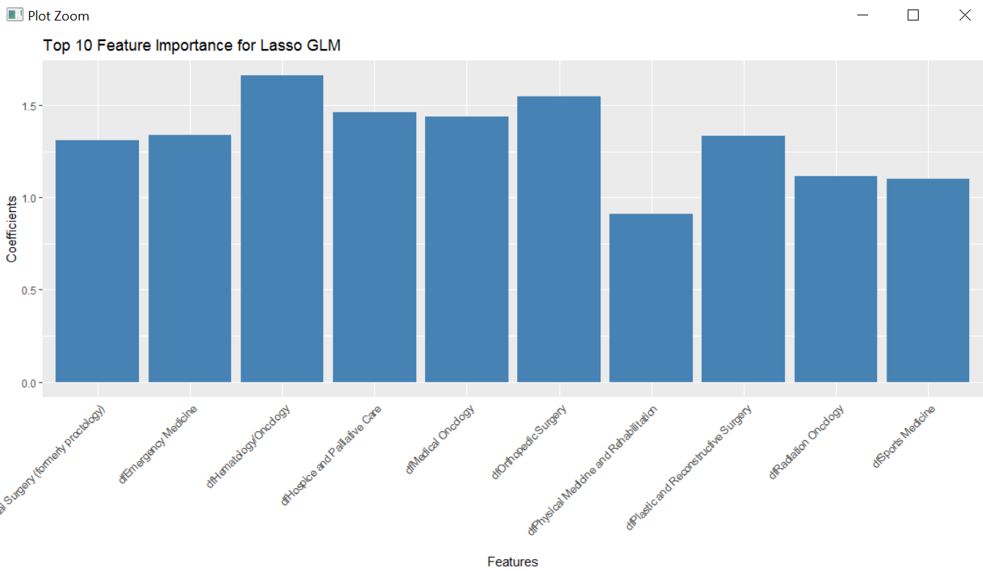

|  |  |
| --- | --- |
|  |  |

STOCHASTIC GRADIENT BOOSTING:

GBM is optimized using caret train control cross validation using 5 folds/no-repeat. It trained very fast and gave a good accuracy.

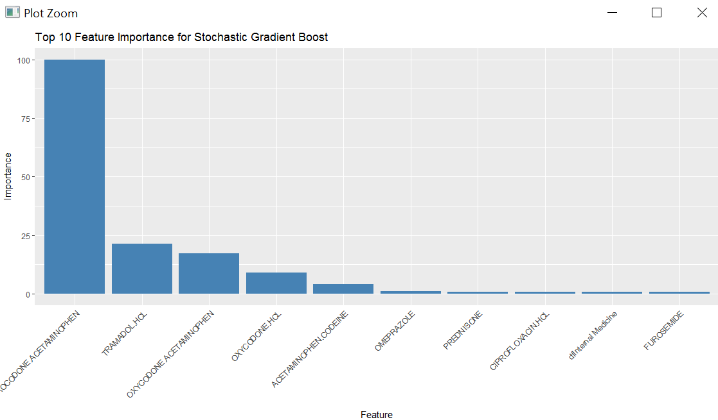

|  |  |
| --- | --- |
|  |  |

ENSEMBLE TECHNIQUE:

Models are ensemble to give a better accuracy.

* H2o package is used for stacking.
* Performance tuned parameters from standalone models are used in stacking instead of cross validating again.
* Base model wrappers are created for each models and parameters
* Meta learner used is logistic regression
* Base models are passed as a list to stack on meta learner.
* Model performance measured was better than standalone models.

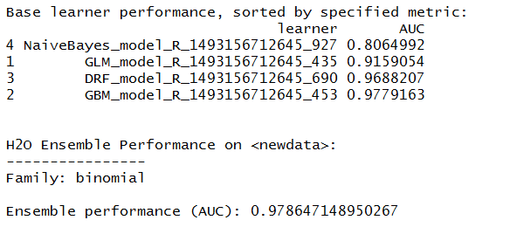

MODEL PERFORMANCE COMPARISON

The figure shows comparative model performance of base models and ensemble. Considering the accuracy and model fit time, ensemble and stochastic gradient boost is a winner.

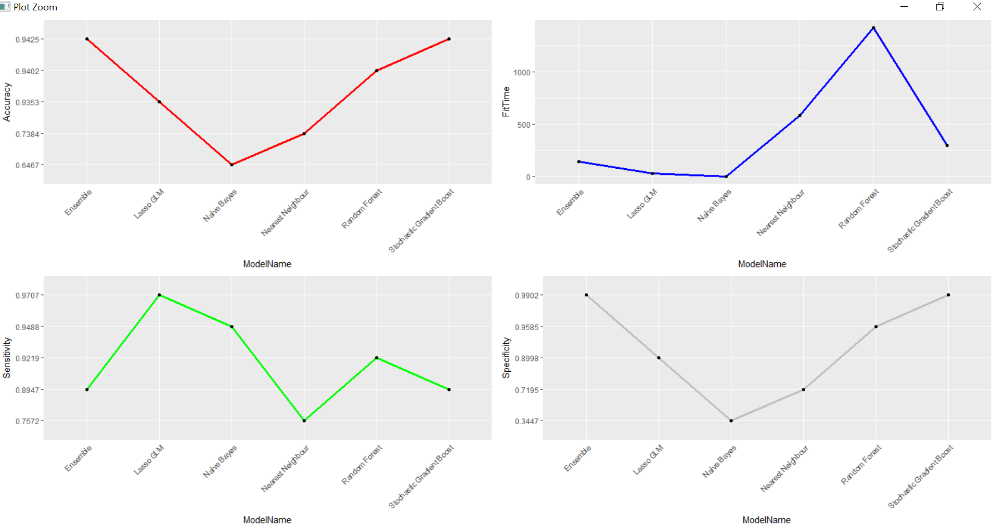

ISSUES

Data Set:

* Features and the data size along with hardware limitations increased the runtime to days.
* Data set required a lot of cleaning to bring it to a suitable format.
* Merging and Data validation was cumbersome.
* Cross validation time on some models was very high even with 5 folds and no repeats.
* Memory issues.

Collinearity:

Due to presence of feature “opioid_claims/refills” all models gave 100% accuracy. Statistically this model was highly important to the target label with zero p-value. However, the reason is unknown as the collinearity could not be established because target label is binary. The models performed realistically after removing this column. More investigation into it is needed.

SUMMARY

* The consumption of opioids is higher amongst white race across all age groups.
* Compounded drugs are to be watched out for.
* HYDROCODONE.ACETAMENOPHEN is a non-opioid drug of paramount importance.
* Female doctors are more inclined to prescribing opiates.
* The U.S. boundary states look more prone to opioid overdose deaths.
* The ensemble model is good predictor of opioid prescriptions with 94.4% accuracy and AUC 97.2%. Stochastic gradient boost works best as a base model.

NEXT STEP & FUTURE WORK

* High number of refills must be related to higher overdose deaths as well as addictions. But this could not be linked to the demographic data. Further investigation is needed.
* There is a relation between opioid deaths and the prescriber’s speciality. Some of the selected specialities are counter intuitive. Domain knowledge will be helpful.
* Model performance can be further improved. Zero variance columns could have been removed beforehand and sub-setting to top 250 drugs could have been expanded.

REFERENCES

* Centre of Medicare and Medicaid services
* Centre for disease control and prevention